# **Running Selenium Automation Tests**

Last Updated 08/17/2021 – Roy Sawyer

## Step 1 : Update From Repository

Depending on what plugin you use to access the svn in eclipse the wording may be slightly different. This step will pull down any changes or new files for the Automation Framework.

* Right Click your project in the Project Explorer pane
* Expand the Team submenu
* Click Update / Update to Head

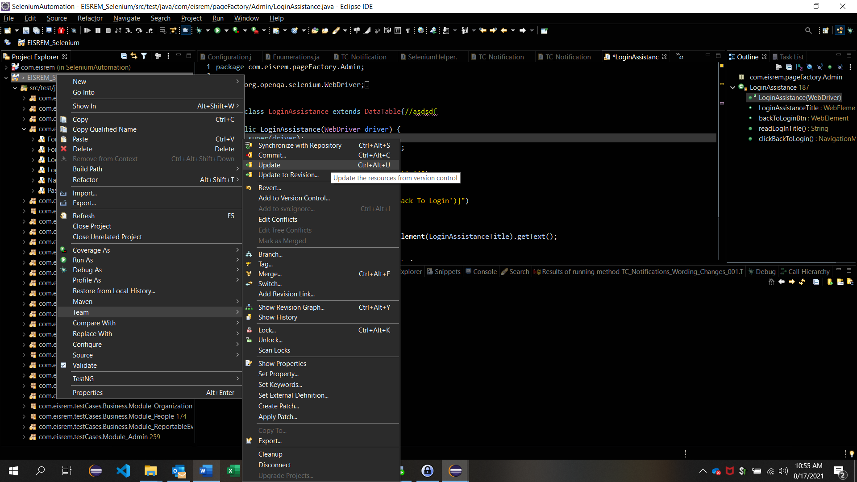

## Step 2: Clean project

It is possible when updating the repository that project will be marked as having errors. To remedy this a project clean is required.

* Click Project in main menu navigation
* Click Clean

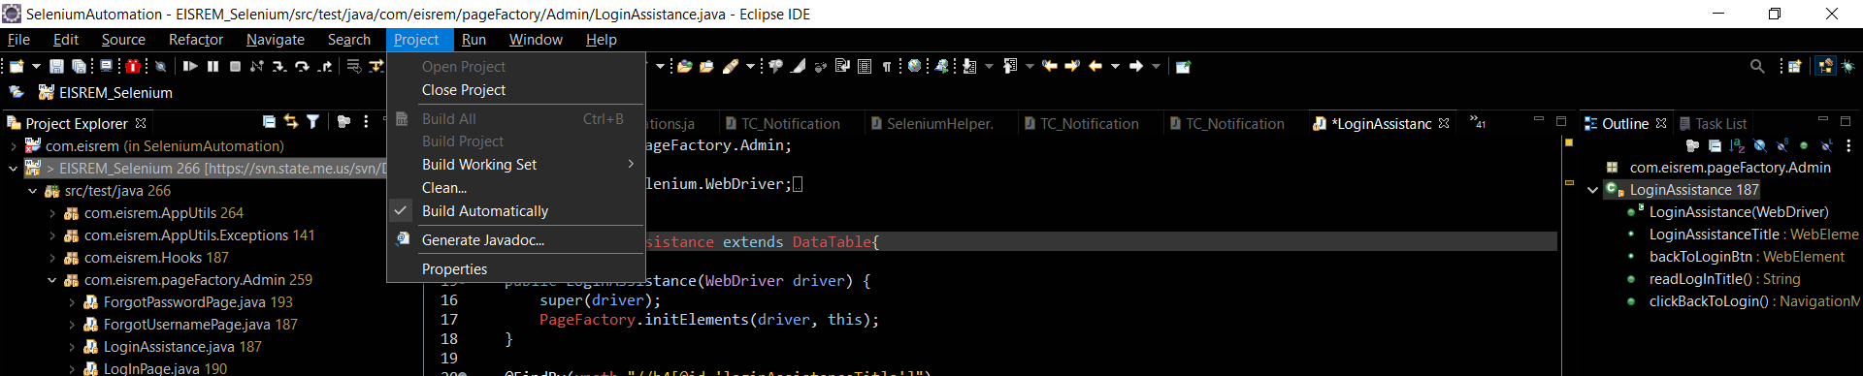

* Clean All Projects should be selected – if not select it
* Click Clean

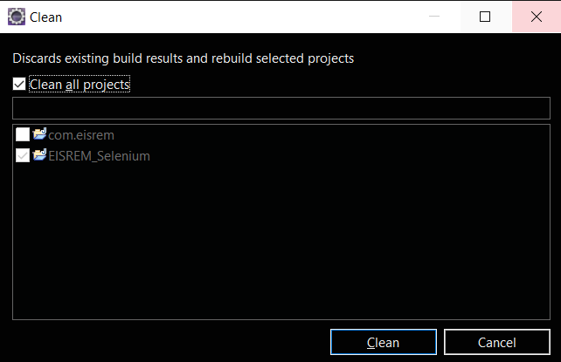

* Wait for clean to finish – It will clean and rebuild the project. Once finished you should not see any information in the progress bar.

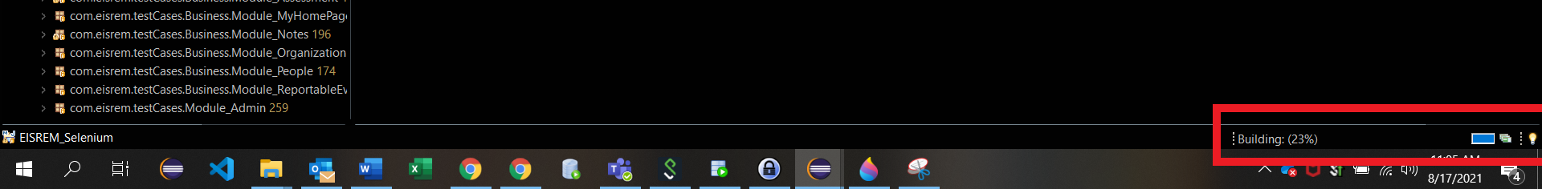

## Step 3: Verify your environment and adjust if needed

In this step you want to make sure that you are testing in the correct environment. For business this would be UAT.

* Expand EISREM_Selenium
* Expand src/test/java
* Expand com.eisrem.AppUtils
* Double click Configuration
* Make sure baseEnviornment = uatEnviornment if not type it as below
* Click the Save icon

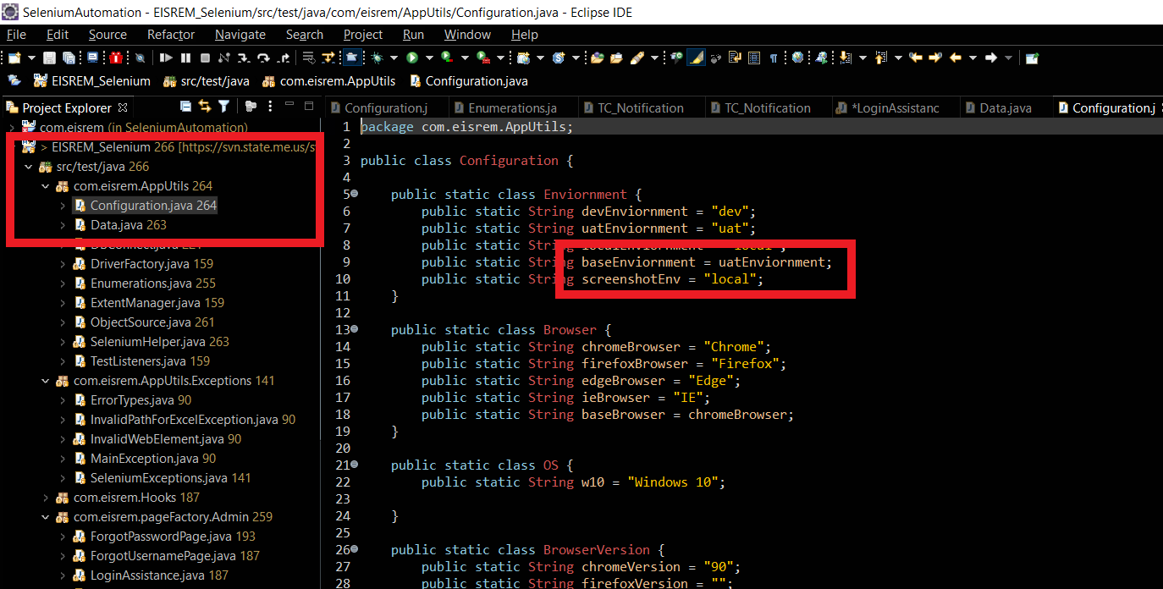

## Step 4: Running a test

This step is for running a test assigned to a BHOPS ticket.

* Expand the Release section with the current release tests in Project Explorer
* Double Click the Test you wish to run to Open the Test
* Click Run to begin the test

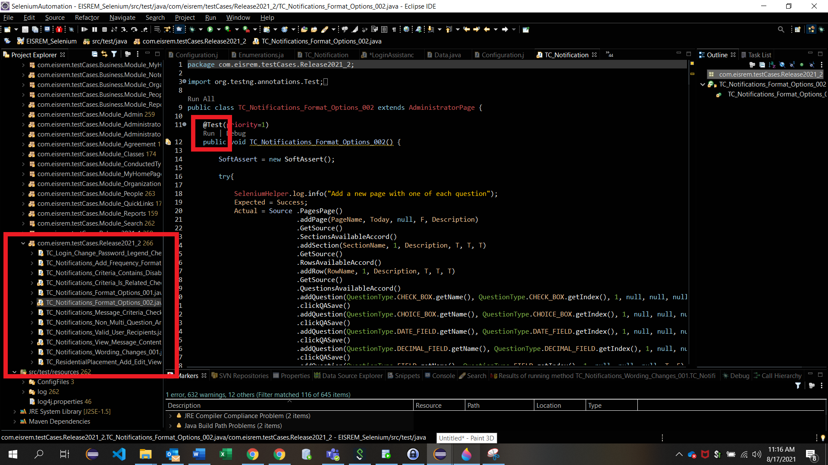

The test should run and you should be able to follow along with the excel file.

## Excel File Locations

Excel files are stored in Teams under Selenium Testing

* Click Teams in the left Navigation Menu
* Click Selenium Testing under MaineIT- OCFS - IS Team
* Click Files in Selenium Testing tab

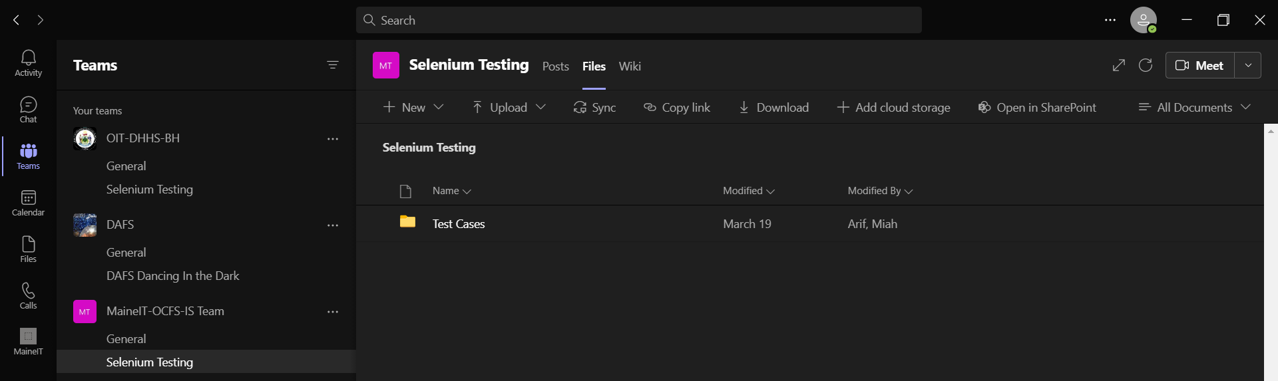

* Click Test Cases
* Click Tests By Release
* Click the current Release
* Either Click the test to open the excel or Right Click the test and Click Download to save a copy of the excel

